COMPARATIVE STUDY OF SUSTAINABLE CONSTRUCTION WITH ECOLOGICAL AND CERAMIC BRICKS

SANTANA, Heloísa Victória Reis
Centro Universitário Presidente Antônio Carlos (UNIPAC)
heloisavictoria3@gmail.com

CABRAL, Raíssa Nascimento
Centro Universitário Presidente Antônio Carlos (UNIPAC)
raissacabral@yahoo.com.br

REIS, Elvys Dias
Centro Federal de Educação Tecnológica de Minas Gerais (CEFET-MG)
elvysreis@yahoo.com.br

RESENDE, Heron Freitas
Universidade Federal de Minas Gerais (UFMG)
heronfr@hotmail.com

ABSTRACT
The construction sector is responsible for major environmental impacts, therefore, studies aimed at sustainability seeking new forms of construction with low environmental impact have been gaining space. The ecological brick uses soil in much of its composition and thus emerges as a sustainable alternative and also as a way to make housing more affordable since it is produced through a simplified construction technique, generating lower economic value and speed in the construction process. Within this context, to compare conventional and ecological masonries, an architectural project of a residential building was proposed, in which the costs for its construction were estimated and compared, demonstrating that the use of ecological brick is economically feasible. Tests of compressive strength and absorption were also performed with the ecological bricks, and their results met the normative requirements, being higher than those of conventional bricks. Besides all the benefits for the environment, the prices of soil-cement bricks showed a savings of 31% compared to conventional bricks.
Keywords: Sustainability. Soil-cement brick. Popular Housing.

1. INTRODUCTION
The use of ecological bricks has been an alternative for the reduction of environmental impacts generated directly or indirectly in civil construction (Lima, 2016). According to Botinas (2017), civil construction is one of the main responsible for the high levels of CO₂ emitted in the process of manufacturing materials and, after construction, in the high production of waste, without proper management. The Brazilian Association of Portland Cement (ABCP, 1986) defines soil-cement brick as a product derived from the mixture of soil, cement, and water, which must be proportioned according to specifications, to acquire strength and durability. Fiais and Souza (2017), in turn, state that the bricks are so-called because there is no need for burning in its manufacturing process, also eliminating the cutting of trees. However, it is highlighted that there is a burning in the manufacturing process of the Portland cement that is incorporated into the mixture, so there are still damages to the environment.
Santana Filho et al. (2018) highlight the importance of the ecological brick for the ecosystem because its cleaner manufacturing process and the use of sustainable raw materials are factors that contribute to the environment. Results of studies show that the use of waste generated by construction and even other raw materials originates a good and effective product, besides minimizing the use of natural resources, thus making the brick a highlight concerning sustainability (Weber et al., 2017). Santana et al. (2013) also highlight the reuse of what is considered as leftovers from construction, which can be incorporated again in the manufacturing process. With this, 100 ecological bricks are equivalent to 2.5 m³ of already discarded material that can be reused. According to Santos and Chaves Júnior (2018), to manufacture one unit of ecological brick, 3.75×10⁻⁵ m³ of waste is produced, while for the production of one ceramic brick, 5.5×10⁻⁵ m³ is generated. With this perspective, Santana et al. (2013) estimated the number of bricks needed to build a 60 m² building and concluded that it would be necessary to use 1500 units of ceramic bricks or 3420 ecological bricks.
It is known that population growth contributes to a large increase in the housing deficit, reaching values of up to six million dwellings, according to data from the João Pinheiro Foundation (FJP, 2016). Therefore, it is increasingly necessary to study materials with low energy consumption, good durability and that are ecological, besides meeting the requirements related to infrastructure, thus becoming the great challenge of the 21st century in developing countries (Anjos et al., 2003). Thus, the soil-cement brick also encompasses the purpose of addressing the need and the search for materials that are more affordable to the population, emerging as a solution to improve the housing deficit. According to Colares (2017), another positive evidence of the new techniques are the better performances, if compared to traditional construction techniques, by maximizing profits and reducing labor.
Given the above and considering the importance of sustainable construction today, this study compares the mechanical strength and costs of a building executed with ecological bricks and a similar one executed with conventional ceramic brick masonry, addressing a project that fits the guidelines of a low-cost housing construction program. Tests were performed to measure compressive strength and water absorption of ecological bricks.
2. EXPERIMENTAL STUDY
The ecological bricks were provided by the company Minas Eco, in Conselheiro Lafaiete, Minas Gerais (Brazil). They have dimensions 7×12.5×25 (cm) and their manufacture follows the requirements of the Brazilian standard NBR 8491 (ABNT, 2012a). Compressive strength and water absorption tests were performed, in the Laboratory of Experimental Analysis of Structures (LAEEs) of the Federal University of Minas Gerais (UFMG), based on the NBR 8492 standard (ABNT, 2012b), to perform a technical analysis of the results and compare them with conventional brick data.
The NBR 8492 standard (ABNT, 2012b) determines that seven test specimens should be made for the compression test, and each one should be sectioned in half, parallel to the smallest direction, and overlaid with a layer of Portland cement paste of no more than 3 mm. After hardening, the bricks should be immersed in water and, after six hours, removed and superficially dried in no more than three minutes. Then they should be centered in the test machine (hydraulic press) for the uniform application of a 500 N/s load, which is gradually increased until rupture. The compressive strength ($f_{c}$) values are obtained from Eq. 1, in which $F$ is the breaking load, expressed in Newtons (N), and $S$ is the application area without discounting the holes, as established by the standard, in mm².
$$f_{c} =\frac{F}{S}$$ | (1)
For the water absorption test, the NBR 8492 standard (ABNT, 2012b) recommends the use of three bricks, which should be dried in an oven until a temperature of 105 to 110 ºC is reached, thus obtaining the mass of the dry specimen ($m_{1}$). Soon after, it must be immersed in a tank for 24 hours, and this action should only be performed when the specimen reaches room temperature again. After this time has elapsed, the brick is removed from the water, the excess surface water is removed and it is weighed to find the wet mass of the specimen ($m_{2}$). Thus, the individual values of water absorption ($A$) can be obtained using Eq. 2 (ABNT, 2012).
$$A=\frac{m_{2}-m_{1}}{m_{1}} 100$$ | (2)
With the results obtained, an average is calculated with the results of each test, which can be used for future comparisons and relevant determinations.
The NBR 8491 standard (ABNT, 2012a) establishes that in compressive strength tests the individual values cannot be less than 1.7 MPa, and the average of the results obtained cannot be less than 2.0 MPa, with a minimum age of 7 days. In water absorption tests, the individual values cannot be higher than 22%, and the average of the results obtained cannot be higher than 20%, with a minimum age of 7 days.
3. DESIGN AND BUDGET
To compare the fixed costs between these building materials, ecological and conventional brick, a floor plan of a residential building was prepared (Figure 1a), which was then dimensioned and its materials were quoted based on the values of the region of Conselheiro Lafaiete, Minas Gerais (Brazil). In the dimensioning of the building using ecological bricks, pillars were adopted every 1 meter, where the spaces with openings were adapted, and also columns were added at the wall junctions, using 3 bars, and hooks every 0.50 m of the wall to make the ties. In the places of the beams, channel bricks were used, below and above the windows and in the top row, using two bars. This structural conception is shown in Figure 1b.
The cost comparison was made considering the material needed for the construction of the two buildings using conventional masonry (ceramic brick) and ecologic brick, not considering the foundation, roof, electrical, and plumbing installation, since for both the values would be the same, not changing the final value of the work for comparison purposes.
It should be noted that the masonry in ceramic brick includes some processes that are not performed in the ecological brick, such as plastering, rendering, and roughcasting. Thus, the values for these services, including labor, since more time is needed to perform these processes, were considered only in the budget of the conventional masonry system.
Once the dimensioning was done, the materials for each system were budgeted according to the SETOP (2021) spreadsheet, of July 2021, for a constructed area of 49 m². Ecological bricks laid with mortar were considered, and the materials for laying ceramic bricks were included in the cement, sand, and lime.
Figure 1: Residential building – a) Architectonic project; b) Structural conception
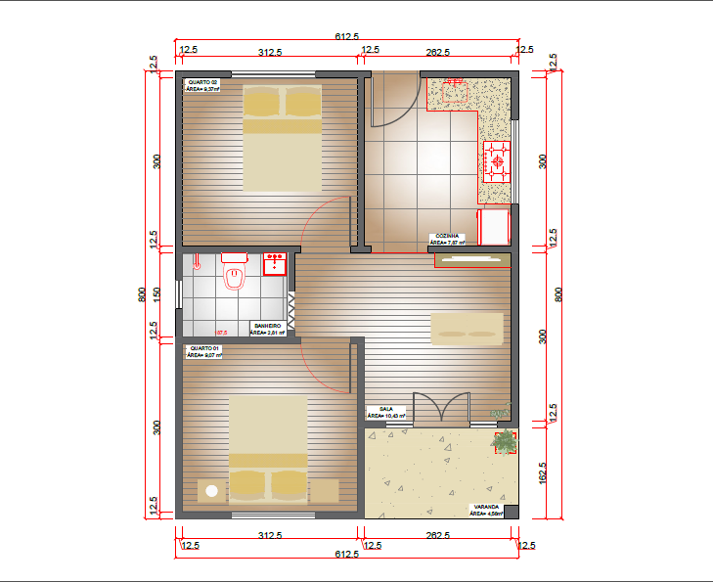 | 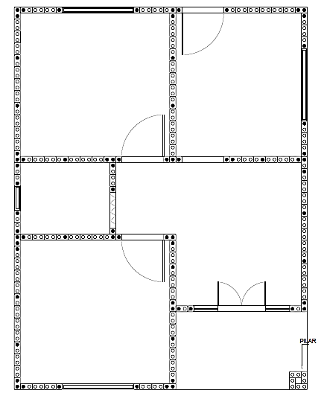
a) | b)
Source: Authors (2021)
4. RESULTS AND DISCUSSIONS
4.1. COMPRESSIVE STRENGTH AND ABSORPTION
In the compressive strength tests ($f_{c}$), the force acting area ($S$) is equal to 15.625 mm², following the procedure of sectioning the brick in half. Figure 2 shows the test setup of one of the specimens in the universal machine, while Table 1 shows the results obtained by Eq. 1.
Figure 2: Compressive strength ($f_{c}$) test
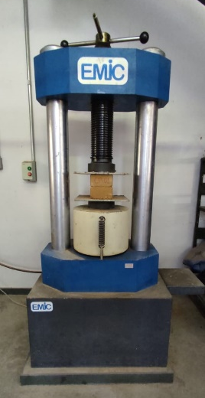
Source: Authors (2021)
Table 1: Compressive strength ($f_{c}$) results
Specimen | Ultimate load (N) | Compressive strength (MPa)
CP1 | 42603.31 | 2.73
CP2 | 47791.71 | 3.06
CP3 | 39681.00 | 2.54
CP4 | 43594.01 | 2.79
CP5 | 27169.63 | 1.74
CP6 | 37412.72 | 2.39
CP7 | 45111.85 | 2.89

As shown in Table 1, seven specimens were used and the average compressive strength found was 2.59 MPa, following the normative provisions. The individual values could not be lower than 1.7 MPa, so they are also in agreement. The standard deviation obtained was 0.435, indicating that there is a small dispersion of the data around the mean.
It is noteworthy that these values may have been influenced by the fact that there is no grinding machine in the laboratory, so the cutting of the bricks was performed with a hacksaw, which does not allow for such a precise cut, in addition to its protruding edges, which also make it less flat and may have affected the result. In addition, the fact that the bricks are very heterogeneous and visibly more porous in some areas means that at these points it will break faster and, consequently, can also affect the strength values. The heterogeneity of the material, specifically, makes it interesting to perform tests with a larger number of specimens.
Lima and Oliveira (2018) also performed compressive strength tests, but with conventional bricks. They used ceramic bricks from three manufacturers in the micro-region of the Vale do Assú, Rio Grande do Norte (Brazil), all of them with eight horizontal holes and with dimensions of 9×19×19 (cm). The average values for each manufacturer were 0.68 MPa, 2.56 MPa, and 0.6 MPa. As the Brazilian standard NBR 15270-1 (ABNT, 2017) specifies an average value of compressive strength equal to 1.5 MPa, it can be seen that two of the companies were below the normative limit and only the second obtained satisfactory results. Souza (2019) also provided compressive strength values for ceramic bricks from the region of Rio Verde, Goiás (Brazil), which showed an average strength of 0.86 MPa and, therefore, were below the specifications of NBR 15270-1 (ABNT, 2017).
For the water absorption test, six specimens were used to obtain a more accurate result. Figure 3 presents the submerged soil-cement bricks, while Table 2 presents the results obtained by Eq. 2.
Figure3: Ecological bricks immersed in water
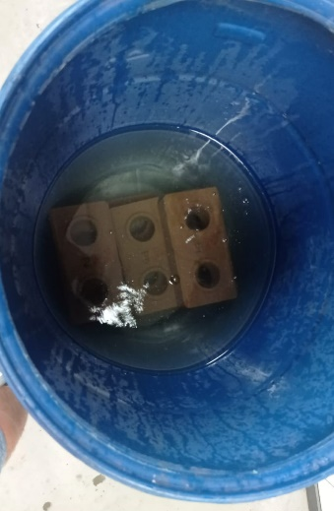
Source: Authors (2021)
Table 2: Absorption ($A$) results
Specimen | Dry weight | Weight after immersion (24h) | Absorption
CP1 | 2.56 | 3.12 | 21.88%
CP2 | 2.62 | 3.14 | 19.85%
CP3 | 2.74 | 3.22 | 17.52%
CP4 | 2.78 | 3.24 | 16.55%
CP5 | 2.56 | 3.06 | 19.53%
CP6 | 2.60 | 3.10 | 19.23%

The results of Table 2 result in a mean value of 19.09%, which is within the normative determinations, as well as individual values of less than 22%. The standard deviation obtained was equal to 1.87%, showing that the values are very little dispersed around the average, which ensures the reliability of the results.
In this context of comparison with ceramic bricks, the NBR 15270-1 standard (ABNT, 2017) determines that the water absorption index of ceramic bricks should not be lower than 8% nor higher than 22%. Tests conducted by Souza (2019) showed an average value of 17.92% water absorption of conventional ceramic bricks. In the tests of these authors, three specimens were used and the results had a standard deviation of 0.11%, therefore, a fairly homogeneous sample, which presents good results. The brick used has dimensions of 9×18×28 (cm), with horizontal holes, which is commonly used in the region of Rio Verde, Goiás (Brazil), where the tests were performed, whose procedure is the same performed for the ecological brick. Brito et al. (2018) also provide positive values regarding the water absorption of bricks from the Paraíba (Brazil) region. Their tests were performed with eight-hole bricks from five factories in the region, obtaining results ranging from 8.78% to 12.75%, also obeying the limit allowed by the standard.
When a comparison is made between the ecological bricks and ceramic bricks, related to water absorption, the values are very close and both fit within the limits and determinations of the standards. Therefore, when analyzing the parameters studied in this paper, the ecological brick becomes a viable option, not causing damage related to moisture, which can affect the aesthetics of buildings, contribute to the proliferation of bacteria and even affect the strength of masonry.
Soares et al. (2003) point out that the mutability of results is related to the brick production stages: non-homogeneity of the raw material mixtures, molding humidity, poor drying, temperature variation, and firing time, among others.
So, when it comes to the resistance of the materials, the ecological brick becomes attractive, since it meets the normative values and has resistance values higher than necessary, while the ceramic often does not reach the established results. So, it is of utmost importance that there is greater control of production and that tests are performed to verify the real efficiency of the material used. The lack of technological control can generate a material that does not meet the specifications for safe masonry, thus, Brito et al. (2018) emphasize the importance of performing and verifying these tests for the construction of good quality buildings and to avoid future setbacks regarding masonry. Gomes Júnior et al. (2017) also emphasize the importance of controlling water absorption, since failure to comply with normative recommendations can lead to pathologies in masonry, and can reduce its compressive strength since excessive moisture impairs the adhesion of bricks and makes them prone to the increase of cracks.
4.2. COMPARATIVE BUDGET
Tables 3 and 4 show the budget made for each type of masonry. Results show that the use of soil-cement bricks leads to a reduction of 31.06% of the final value when compared to ceramic brick. This reduction can be explained by several factors, including the aspect of the finishing of the ecological brick, which can be done only with the application of resin, and its function of camouflaging the structural part, not being necessary expenses with wood for formwork.
Figure 4 presents the detailed difference between the two methods, and the distinctions highlighted above are emphasized by the results. It is possible to see that even with a big difference between masonry prices, ecological brick is still a great option since the economy in the superstructure equals the two masonries. Employing the value of the square meter (m²) as the main comparative, it is noted that the ceramic brick has a significant increase concerning the use of ecological brick, about 45% more.
Table 3: Budget for the ecological brick system
No | Description | Unit | Amount | Price per unit | Total price
1 | Superstructure
1.1 | Gravel | m³ | 0.5 | R$ 139.50 | R$ 69.75
1.2 | Cement - 50 kg | un | 11 | R$ 33.00 | R$ 363.00
1.3 | Sand | m³ | 1.5 | R$ 112.00 | R$ 168.00
1.4 | Reinforcement for pillars - 8 mm | bar | 19 | R$ 52.90 | R$ 1,005.10
1.5 | Reinforcement for channels - 5 mm | bar | 25 | R$ 25.90 | R$ 647,50
 | Subtotal |  |  |  | R$2,253.35
2 | Masonry
2.1 | Ecological brickwith 2 holes | un | 6,120 | R$ 1.45 | R$ 8,874.00
2.2 | Channel type brick | un | 634 | R$ 1.45 | R$ 919.30
 | Subtotal |  |  |  | R$9,793.30
3 | Complementary materials
3.1 | Mortar - 20 kg | un | 26 | R$ 16.90 | R$ 439.40
3.2 | Grout - 1 kg | un | 79 | R$ 4.90 | R$ 387.10
3.3 | Finishing resin - 20 liters | un | 80 | R$ 267.90 | R$ 1,071.60
 | Subtotal |  |  |  | R$1,898.10
 | Total price |  |  |  | R$ 13,944.75
Table 4: Budget for the ceramic brick system
No | Description |  |  |  | Unit |  | Amount |  |  |  | Price per unit |  |  |  |  | Total price
1 | Superstructure
1.1 | Gravel |  |  |  | m³ |  | 5 |  |  |  | R$ 139.50 |  |  |  |  | R$ 697.50
1.2 | Cement (50 kg) |  |  |  | un |  | 5 |  |  |  | R$ 33.00 |  |  |  |  | R$ 165.00
1.3 | Sand |  |  |  | m³ |  | 5 |  |  |  | R$ 112.00 |  |  |  |  | R$ 560.00
1.4 | 10 mm reinforcement |  |  |  | bar |  | 16 |  |  |  | R$ 70.00 |  |  |  |  | R$ 1,120.00
1.5 | 8 mm reinforcement |  |  |  | bar |  | 16 |  |  |  | R$ 52.90 |  |  |  |  | R$ 846.40
1.6 | 6.3 mm reinforcement |  |  |  | bar |  | 6 |  |  |  | R$ 32.90 |  |  |  |  | R$ 197.40
1.7 | 5 mm reinforcement |  |  |  | bar |  | 51 |  |  |  | R$ 25.90 |  |  |  |  | R$ 1,320.90
 | Subtotal |  |  |  |  |  |  |  |  |  |  |  |  |  |  | R$4,907.20
2 | Masonry
2.1 | Ceramicbrick |  |  | un |  | 2,364 |  |  |  | R$ 1.40 |  |  |  |  | R$ 3,309.60
 | Subtotal |  |  |  |  |  |  |  |  |  |  |  |  |  | R$ 3,309.60
3 | Complementary materials
3.1 | Painting |  |  | m² |  | 21.6 |  |  |  | R$ 342.00 |  |  |  |  | R$ 342.00
3.2 | Roughcast with mortar, 1:3 proportion (cement and sand), 5mm thick, applied on masonry with sieve, mechanical preparation (SETOP REV-CHA-010) |  |  | m² |  | 10.12 |  |  |  | R$ 188.28 |  |  |  |  | R$ 1,905.39
3.3 | Plastering with mortar, proportion 1:6 (cement and sand), 20mm thick, manual application, mechanical preparation (SETOP REV-EMB-005) |  |  | m² |  | 25.73 |  |  |  | R$ 188.28 |  |  |  |  | R$ 4,844.44
3.4 | Plastering with mortar, proportion 1:2:8 (cement, lime and sand), 20mm thick, manual application, mechanical preparation (SETOP REV-REB-015) |  |  | m² |  | 26.12 |  |  |  | R$ 188.28 |  |  |  |  | R$ 4,917.87
 | Subtotal |  |  |  |  |  |  |  |  |  |  |  |  |  | R$12,009.71
 | Total price |  |  |  |  |  |  |  |  |  |  |  |  |  | R$20,226.51

Figure 4: Budget comparison for building with ceramic and ecological bricks

These results prove the importance of the ecological brick building system, since, besides having a lower consumption of materials, it speeds up the construction process and does not cause the generation of large amounts of debris like the ceramic brick, which is a great incentive for its application. This fact is also corroborated by the environmental issue that involves them since for the manufacture of the ecological brick there is no burning during its cure. Still citing the positive highlights, it is necessary to emphasize the large deficit of housing, for which the soil-cement brick can be an ally in the decline of this indicator.
5. CONCLUSIONS
This paper showed the viability of the use of ecological brick in civil construction since its mechanical properties can be better than those of ceramic brick and also follow the proper normative recommendations.
The laboratory tests showed an average compressive strength of the ecological brick equal to 2.59 MPa and average absorption equal to 19.09%, acceptable values according to the normative specifications and better than the results obtained by other authors for the ceramic brick. However, it would be important to perform new tests with a larger sample of specimens and a consequent statistical analysis, from which the significance of the results could be verified.
In cost comparison, even though the ecological brick masonry has a higher cost than the ceramic brick, the savings in other stages of the building process, such as cladding, makes it also stand out in this parameter. The price per square meter revealed a difference of approximately 45% between the two types of brick, being the price of the ceramic brick higher.
Finally, there is a need for research and dissemination of information about this construction method, to show consumers in the construction market that it is a masonry option with numerous benefits, including the possibility of improving the Brazilian housing deficit rates.
ACKNOWLEDGEMENTS
The authors wish to thank the Laboratory of Experimental Analysis of Structures (LAEEs) of the Federal University of Minas Gerais (UFMG), as well as the company Minas Eco for supplying the bricks used in the experiments.
REFERENCES
ANJOS, M. A. S. et al. Cement-based composites reinforced with bamboo cellulose pulp. Part II: Use of ceramic waste in the matrix. Brazilian Journal of Agricultural and Environmental Engineering, Campina Grande v. 7, n. 2, p. 346-349, 2003. (in Portuguese)
BOTINAS, Rui de Abreu. Study of soil as a sustainable construction material. Master thesis. Faculty of Science and Technology University of Coimbra. Coimbra, 2017. (in Portuguese)
BRAZILIAN ASSOCIATION OF TECHNICAL STANDARDS (ABNT). NBR 15270-1: Ceramic components - Blocks and bricks for masonry - Part 1: Requirements. ABNT, Rio de Janeiro, 2017. (in Portuguese)
BRAZILIAN ASSOCIATION OF TECHNICAL STANDARDS (ABNT). NBR 8491: Soil-cement bricks - Requirements. ABNT, Rio de Janeiro, 2012a. (in Portuguese)
BRAZILIAN ASSOCIATION OF TECHNICAL STANDARDS (ABNT). NBR 8492: Soil-cement bricks - Dimensional analysis, determination of compressive strength and water absorption - Test method. ABNT, Rio de Janeiro, 2012b. (in Portuguese)
BRAZILIAN PORTLAND CEMENT ASSOCIATION (ABCP). Mix dosage of soil-cement mixtures; dosage standards and test methods. 3rd ed. São Paulo, 1986. 57p. (in Portuguese)
BRITO, W. O. et al. Analysis of the mechanical strength, absorption and efflorescence of bricks in Paraiba. In: Proceedings of the Conference on Pathology and Rehabilitation of Buildings - PATORREB. Rio de Janeiro, 2016. (in Portuguese)
COLARES, R. S. Evaluation of the thermal efficiency of sealing masonry using ceramic bricks. Master thesis. Federal University of the Valleys of Jequitinhonha and Mucuri. Teófilo Otoni, 2017. (in Portuguese)
FIAIS, Bruna Barbosa; SOUZA, Danilo Sarto de. Sustainable construction with ecological brick. Journal Engineering in Action UniToledo, Araçatuba, SP, v. 02, n. 01, p. 94-108, 2017. (in Portuguese)
GOMES JÚNIOR, Francisco Célio Nogueira et al. Checking the quality of hollow ceramic blocks for sealing masonry produced by factories in the city of Crato-CE. In: Proceedings of the National Conference of Pathology and Recovery of Structures. Recife, 2017. (in Portuguese)
LIMA, D. S. J. Analysis of constructive and economic feasibility in the application of soil-cement brick in low-income housing on the island of São Luís. Graduation Paper. Maranhão State University. São Luís, 2016. (in Portuguese)
LIMA, R. A.; OLIVEIRA, M. P. Evaluation of the physical and mechanical properties of ceramic blocks produced by industries in the Assú-RN valley. Graduation Paper.Universidade Federal Rural do Semiárido. Mossoró, 2018. (in Portuguese)
SANTANA FILHO, César Carlos et al. Soil-cement brick: contemporary notes in terms of Brazil. Espacios Magazine, Venezuela v. 39, no. 51, 2018. (in Portuguese)
SANTANA, J.E.S.; CARVALHO, A.C.X.; FARIA, R.A.P.G. Ecological brick versus common brick: Environmental benefits and energy savings during the firing process. In: IV Brazilian Congress of Environmental Management, 2013. (in Portuguese)
SANTOS, E. C. O. B.; CHAVES JÚNIOR, J. M. Mitigation of environmental impacts through the use of ecological building materials. Case study: ecological bricks compared to ceramic bricks. Graduation Paper. UniEvangélica, 2018. (in Portuguese)
SOARES, J. M. D. et al. Mechanical resistance and water absorption of red ceramic products produced in the central region of the State of Rio Grande do Sul.In: Proceedings of Brazilian Ceramics Congress, 2003, p. 965-974. (in Portuguese)
SOUZA, Gabriel Miranda. Comparative analysis of mechanical properties between soil-cement bricks and ceramic bricks. Graduation Paper. University of Rio Verde, 2019. (in Portuguese)
STATE SECRETARIAT OF TRANSPORTATION AND PUBLIC WORKS OF MINAS GERAIS (SETOP). SETOP Prices - Eastern Region - No tax exemption. Available at:http://www.infraestrutura.mg.gov.br/images/documentos/precosetop/2021/07-jul/sem-desoneracao/202107_SETOP_LESTE_SEM_DESONERACAO.pdf.> Accessed on: 26 Sep. 2021. (in Portuguese)
WEBER, Eduardo, et al. Efficiency analysis of soil-cement ecological brick in Civil Construction. IGNIS: Scientific Journal of Architecture and Urbanism, Engineering and Information Technology, Caçador, v. 6, no. 2, p. 18-34, 2017. (in Portuguese)

